Windows Core and AD

# Note

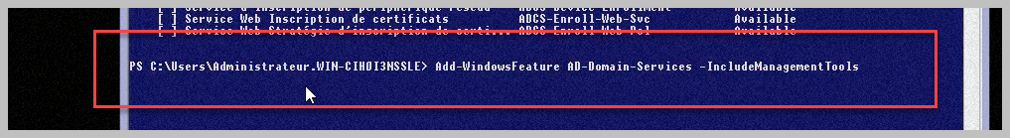

## .Txt File for Domain Deployement

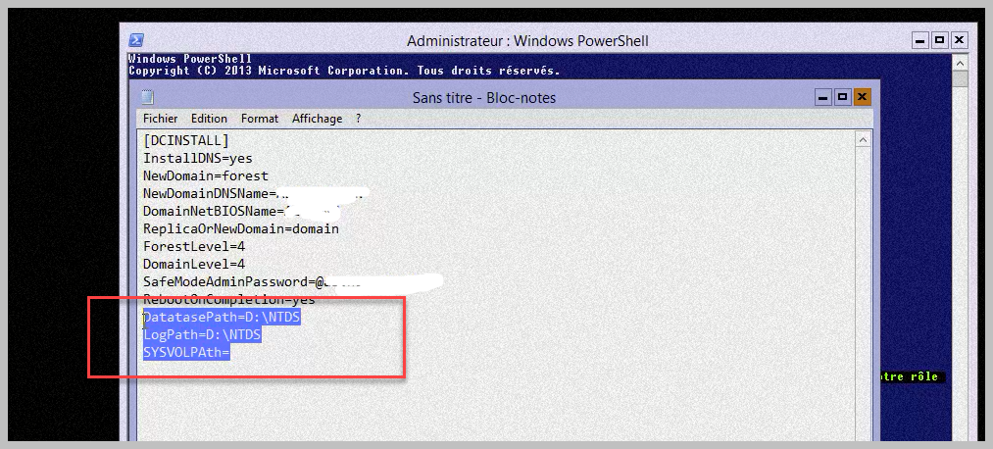

## Configuring Domain via file.txt

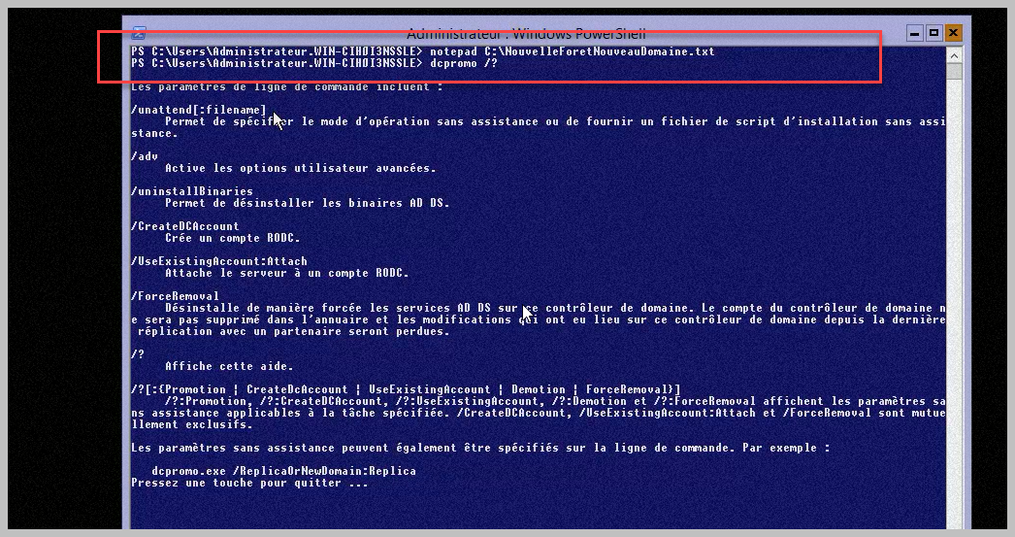

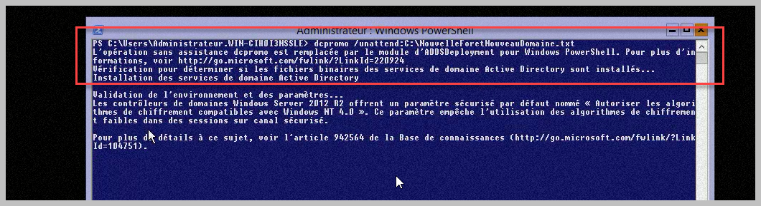

# Rappel netsh

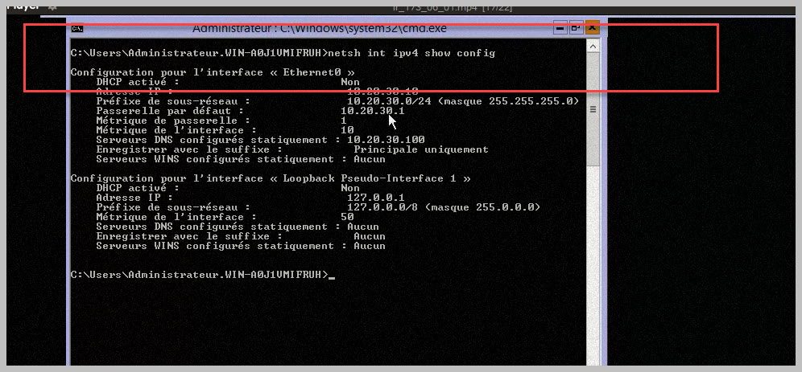

# Replication Domain

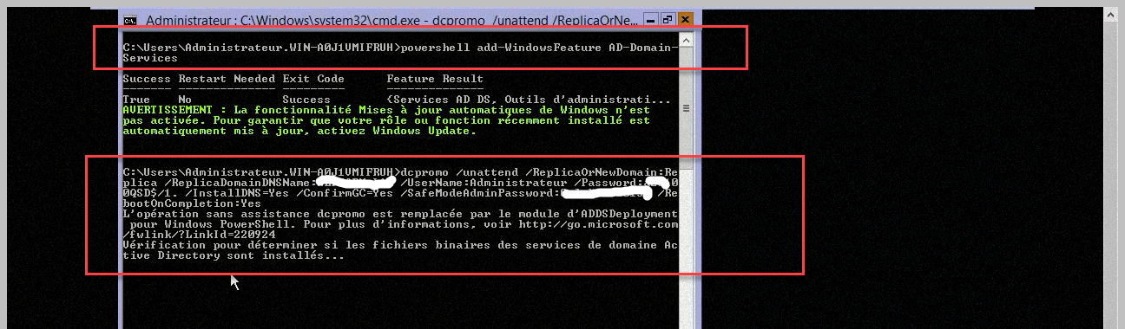

# Adding user to the domain

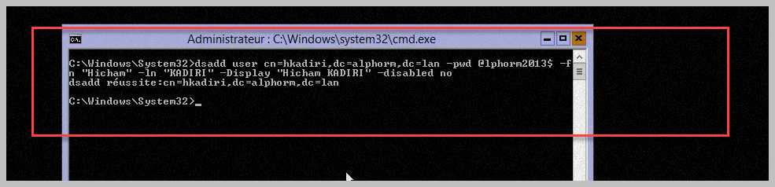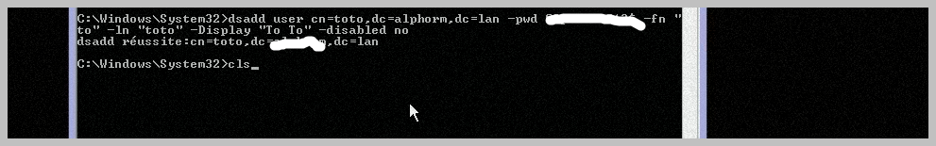

# Dsquery

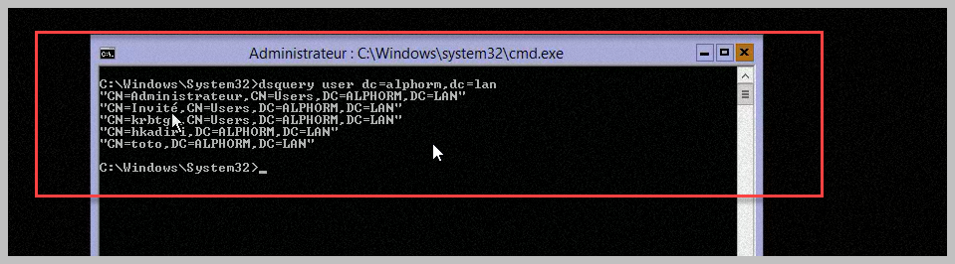

# Ldidf

